Title: A Functional Data Analysis of At-Home Activity and Sleep in Klinefelter Syndrome Patients Versus Age- and BMI-Matched Controls

Authors: Samantha Bothwell ^{1,2}, Karli Swenson ¹, Emma Todd ¹, Mia Middleton ¹, Shanlee Davis ^{1,3}

AFFILIATIONS:
- eXtraOrdinary Kids Turner Syndrome Research and Clinic Team, Children’s Hospital of Colorado, Aurora, Colorado.
- Child Health Biostatistics Core, University of Colorado School of Medicine, Aurora, Colorado.
- Division of Endocrinology, Children’s Hospital Colorado, Aurora, Colorado, Department of Pediatrics, University of Colorado School of Medicine, Aurora, Colorado.

Purpose of the study :
Klinefelter syndrome (KS), 47,XXY, affects 1 in 600 males and is characterized by an additional X chromosome. Men with KS have altered testicular development, deficient testosterone levels, and infertility. They are less physically active than other men, have higher BMIs on average, and report higher levels of fatigue. However, little research has explored the relationship between sleep and activity in KS. This analysis analyzes differences in activity and sleep outcomes between KS cases and non-KS age- and BMI-matched controls.

Methods Used :
KS males and non-KS controls aged 15 - 27 were recruited into the Lipids to Energy (LTE) clinical trial. Groups were age- and BMI- matched. Participants wore ActiGraph accelerometers and ActiWare sleep watches for one continuous week while completing daily surveys on activity, sleep, and diet. ActiGraph accelerometers monitor activity including measures of body position and movement. ActiWare sleep watches monitor sleep and wake time as well as light exposure. The first and last day of wear for each participant were excluded for analysis.

We implement a functional analytic approach to model the difference in activity count and white light exposure over the daily 24-hour period between KS cases and non-KS controls. Minute level data were collected and averaged across the week of data collection within participant. Sleep time measures are summarized as median [IQR] with differences tested with Kruskal-Wallis tests. A type 1 error rate of 0.05 is assumed.

Summary of Results :
Our analysis includes 16 KS and 10 controls with complete activity and sleep watch data over a 7-day time span. There was no evidence of a difference in age, height, weight, or BMI between cases and controls. Controls were significantly more active than KS cases from 4 am to 9 pm, with their most active time periods being 8 am and 6 pm (Figure 1A). KS cases were significantly, though mildly, more active than controls from 9 pm to midnight. There was not, however, sufficient evidence to conclude KS cases went to bed later than controls. KS cases slept longer than controls, though not significantly so, (median [IQR] : 7.9 hrs [6.7, 9.1] vs 7.5 hrs [6.8, 8.3]; p = 0.055) and got out of bed significantly later (median [IQR] : 9:03 AM [7:27 AM, 9:51 AM] vs 7:37 AM [6:33 AM, 8:21 AM]; p = 0.03). Over the 24-hour day period, controls had a significantly higher level of white light exposure from 8 am to 9 pm (Figure 1B).

Conclusions :
Our data suggest that KS males are less active and wake later than controls. The lower activity and delayed waking, in addition to lower white light exposure, may relate to their self-reported fatigue. These findings highlight the importance of understanding fatigue and sleep needs in adolescents with KS. Further analyses will include self-reported measures and explore the impact of activity and sleep on quality of life outcomes.
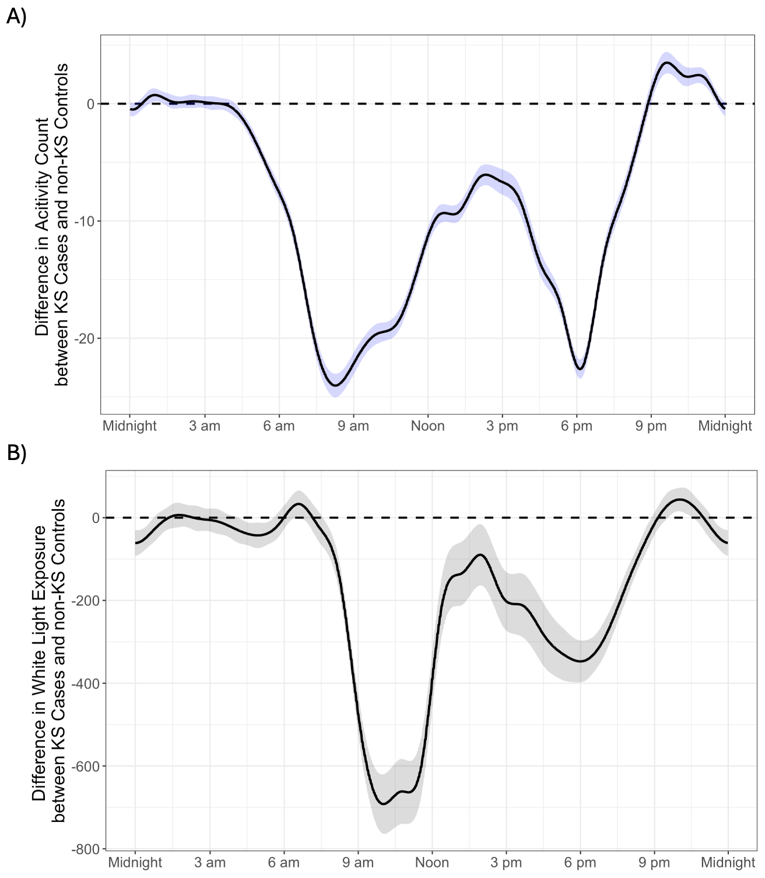
Figure 1.
A ) Function-on-scalar regression beta coefficient for the difference in activity count between KS Cases and non-KS Controls throughout a 24-hour period. Negative values indicate higher activity in non-KS controls while positive values indicate higher activity in KS cases. The blue shaded region represents the 95% confidence interval.
B ) Function-on-scalar regression beta coefficient for the difference in white light exposure between KS Cases and non-KS Controls throughout a 24-hour period. Negative values indicate higher amounts of white light in non-KS controls while positive values indicate higher amounts of white light in KS cases. The grey shaded region represents the 95% confidence interval.

